Delete
Please follow these steps if you wish to delete the project, with Step 2 depending on whether your project is in Development or Production status.

From the Project Setup page, click on the tab “Other Functionality”

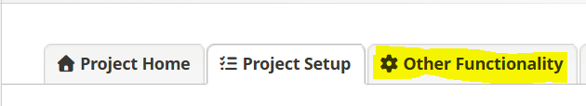
- Development Status -> Delete the project
  - You may completely remove this project, in which all its data will be permanently deleted.
  - To delete a project, the user must have Project Design and Setup Rights for this project
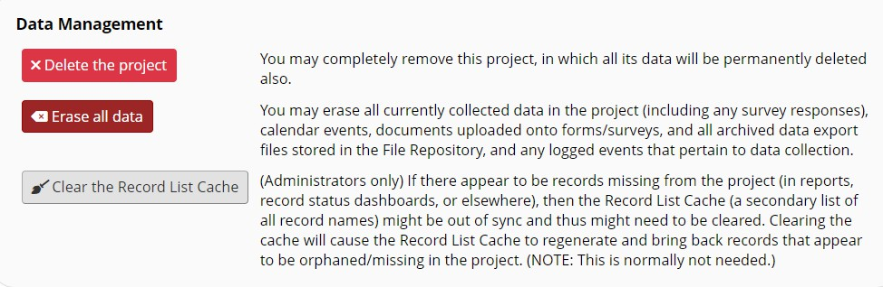

Production Status -> Delete the project
  - You may completely remove this project, in which all its data will be permanently deleted
  - To delete a project, the user must have Project Design and Setup Rights for this project
  - Once a project is Deleted, it cannot be restored

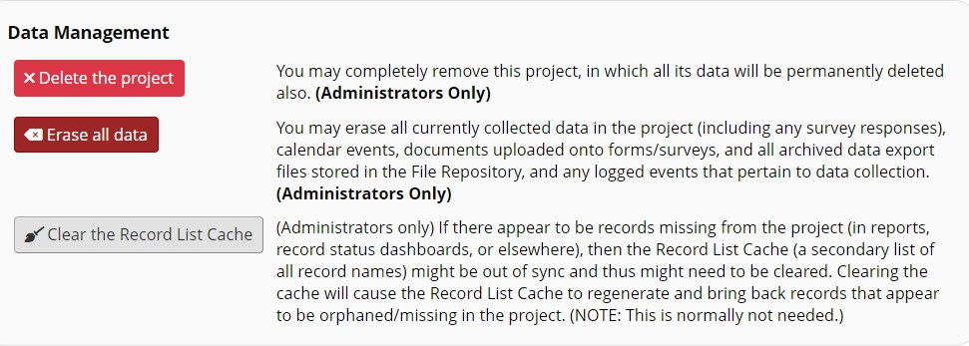

Mark a project as Completed

From the Project Setup page, click on the tab “Other Functionality”

Choose the option “Mark project as Completed”

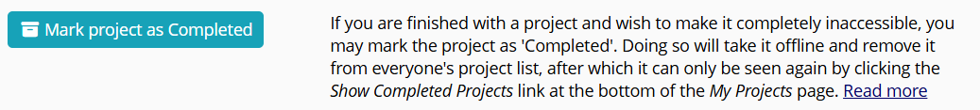

Once marked as Completed, no users (except for REDCap administrators) can access the project and only REDCap administrators may undo the Completion and return it back to an accessible state for all project users. Marking a project as Completed means you want to ensure that the project and its data remain intact for a certain amount of time.

Even though users can’t open Completed projects, a list of Completed projects can still be viewed by clicking on “Show Completed Projects” which is at the very bottom of the “My Projects” list.

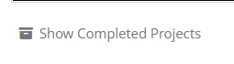

***Any downloaded sensitive information (PII/PHI) must comply with the NJH Data Classification, Handling, and Disposal policy requirements. Details on approved NJH HIPAA-compliant data storage systems is available on RICC’s website. Storing sensitive information on workstations, laptops, or external hard drives is prohibited without authorization from the CIO.***

